**DAILY ONLINE ACTIVITIES SUMMARY**

|  |  |  |  |  |  |  |  |  |
| --- | --- | --- | --- | --- | --- | --- | --- | --- |
| **Date:** | **22-05-2020** | | | | | **Name:** | **Nihal Rafiq** | |
| **Sem & Sec** | **4th A** | | | | | **USN:** | **4AL18CS052** | |
| **Online Test Summary** | | | | | | | | |
| **Subject** | | **Operating System** | | | | | | |
| **Max. Marks** | | **30** | | **Score** | | | **22** | |
| **Certification Course Summary** | | | | | | | | |
| **Course** | **Introducing Coding for Beginners: an HTML and CSS online Course** | | | | | | | |
| **Certificate Provider** | | | **BitDegree** | | **Duration** | | | **60 hours** |
| **Coding Challenges** | | | | | | | | |
| **Problem Statement:**  **1. Write a c or java program to implement round robin type of process scheduling**  **2. Write a c program to implement a various operations on singly linked list stack.** | | | | | | | | |
| **Status: Executed** | | | | | | | | |
| **Uploaded the report in Github** | | | | | **Yes** | | | |
| **If yes Repository name** | | | | | **https://github.com/nihal-art/lockdown-coding** | | | |
| **Uploaded the report in slack** | | | | | **Yes** | | | |

Online Test Details:

The online test was from module 1 which was 30 MCQ questions. The time duration of online test was 40 minutes from 9.15am to 9.55am.The score of the online test is 22/30.

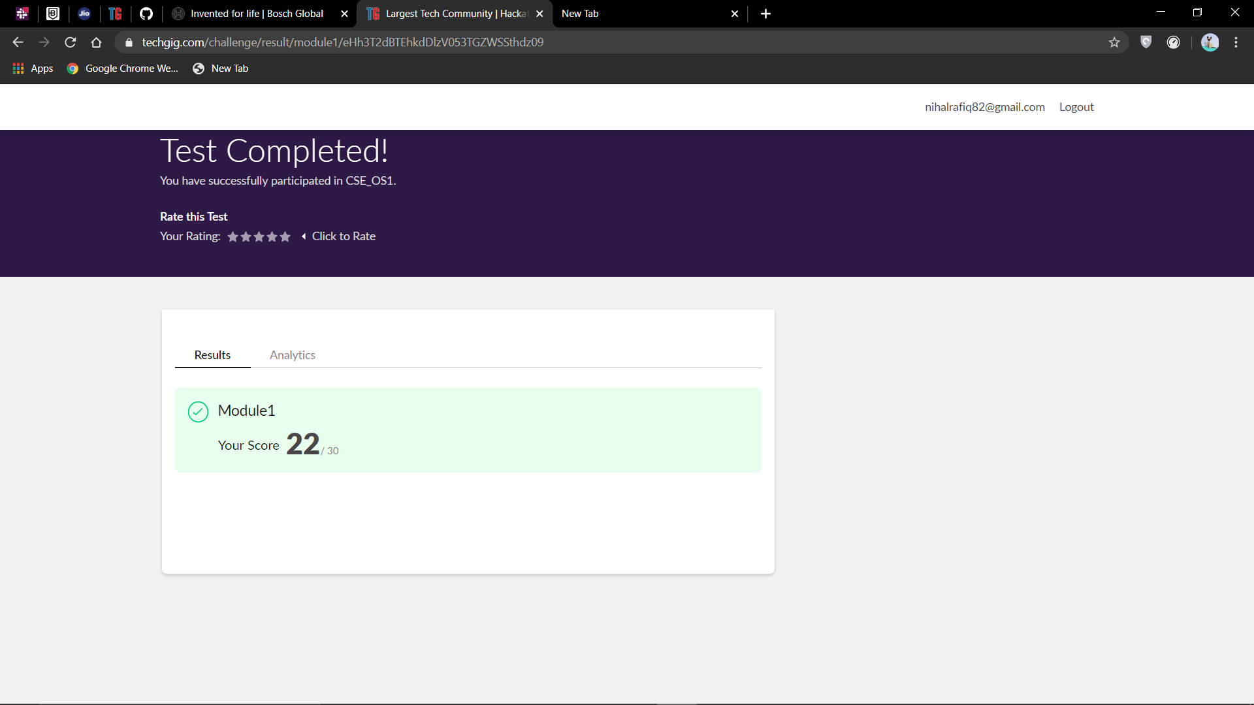

Certification Course Details:

I have opted my Online Certification Course in BitDegree. The course which I have opted is Introducing Coding for Beginners: an HTML and CSS Online Course.

This course covers the following topics:

* Basic web development
* Creating forms, buttons and other elements
* HTML coding basics
* CSS basics

Description: A fun way to get Familiar with Coding for Beginners

Master HTML and CSS basics step-by-step

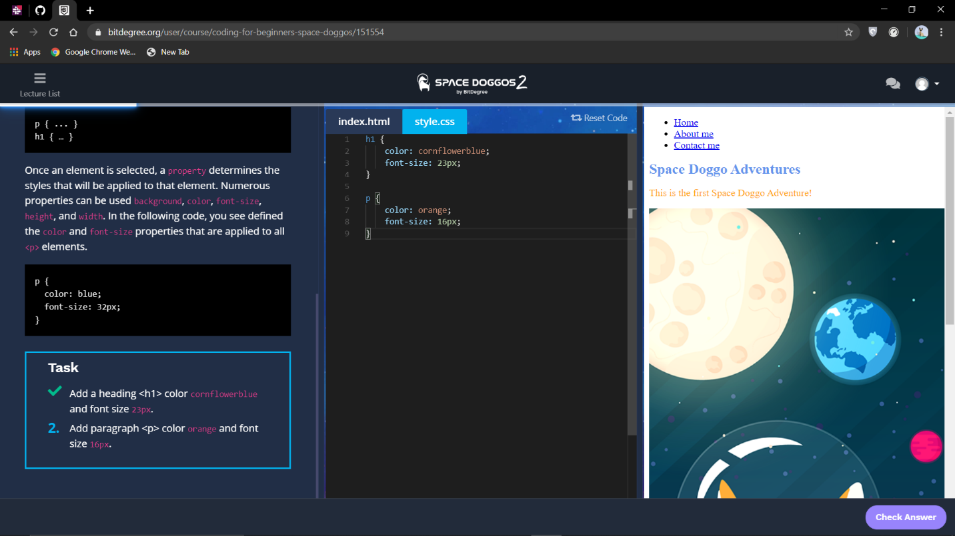

Coding Challenges Details:

1. C program to implement round robin type of process scheduling.

Input: Process with burst time, arrival time and specify the time quantum

Output: Processes scheduled based on the round robin type of scheduling, with its average waiting time

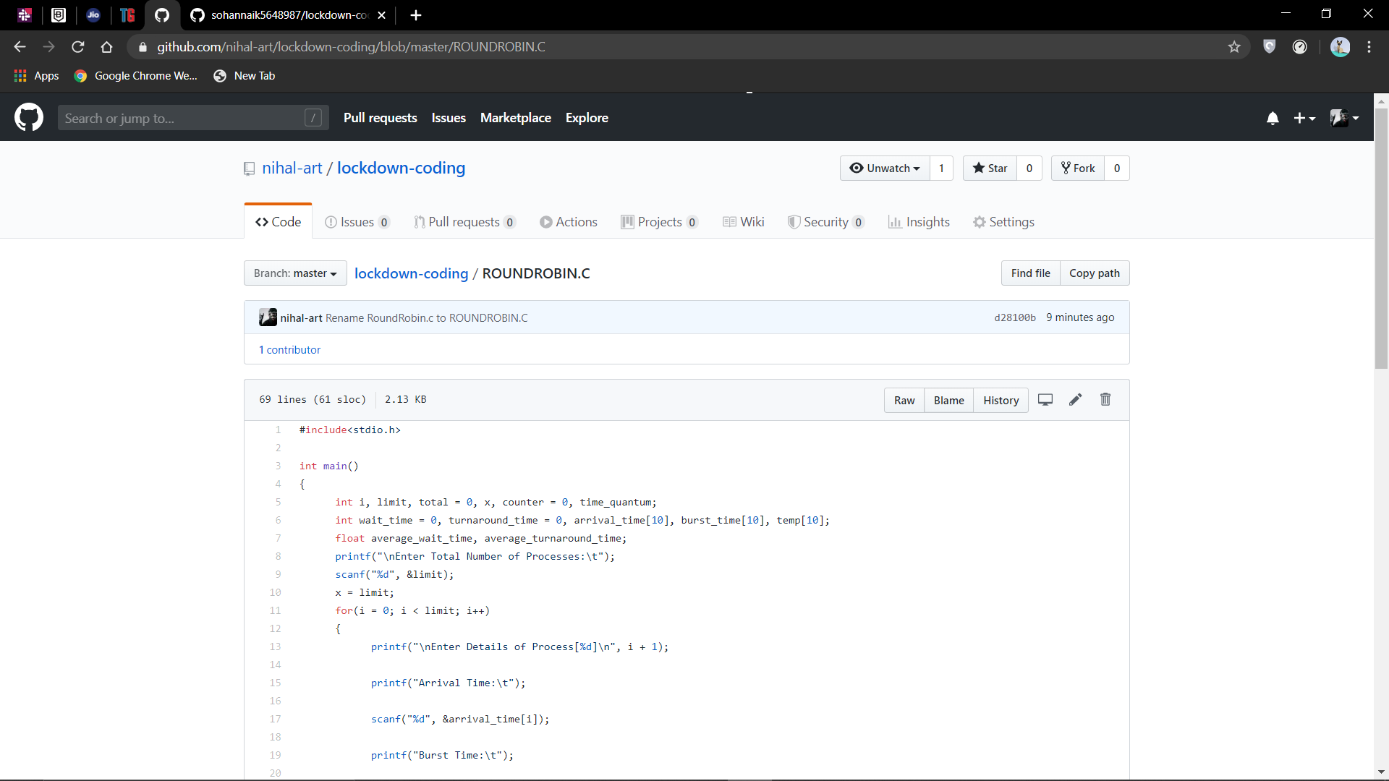

2. C program to implement various operations on singly linked list stack.

